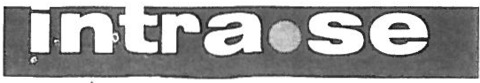

Safety Instructions for Crane Truck 46010

General provisions:

The crane truck has a lifting capacity of max. 2,300 kg at the innermost hook heel and 440 at the outermost crook heel with a fully unfolded telescope. This presupposes that the underlying truck is a forklift truck with a minimum capacity of 3,000 kg.
The load limits for small trucks have also been computed and enclosed herewith. However, it is recommended that

the truck have a capacity of 3,000 kg.
The weight indications on the truck crane refer to trucks with a minimum capacity of 3,000 kg.
The specified maximum loads may not be exceeded.
Please note that the permissible loads during transport are lower than during lifting with the truck standing still. Do not walk underneath suspended loads

Prior to use:
Check carefully that the boom is properly fastened with both the through bolt and the locking peg.
Check that the hook’s attachment points are in good order as well as that the elastic safety bolt of the hook works.
Check that the crane truck has been properly fastened to the truck forks with the accompanying locking chain.

Goods handling:
Make sure that the goods are well-balanced and properly anchored in the truck crane hook.
The handling of goods must be done in a position that is as close to the truck as possible in order to ensure the best possible point of balance. in other words, the telescopic part mast be inserted as far in as possible. Please read thoroughly and heed the capacity table. These values indicate the approved maximum capacity of the truck crane in different positions and with different truck types. Intra disclaims any liability if these values have been exceeded.

Driving:
Drive the truck at the lowest speed during transportation. This applies, in particular, to transportation of goods, but also when driving without a load. It is of utmost importance to prevent the load from swinging around. Pay close attention, especially in case of swinging.
Keep the goods at the lowest height possible so that the truck can maintain as low a center of gravity as possible
and thereby also the best possible stability.
Pay close attention to the movements of the goods, both during lifting and during raising and lowering. A load that starts swinging can cause major damage and poses a hazard for both people and equipment.

EC DECLARATION OF CONFORMITY

IMPORTER: INTRA MATERIALHANTERING AB KARBINGATAN 2
SE-231 66 TRELLEBORG

HEREBY DECLARES THAT INTRA’S FORKLIFT CRANE ARTICLE NO. 46010
AR TILLVERKADE I ÖVERENSSTÄMMELSE MED MASKINDIREKTIVENS SAKERHETSKRAV/
IS PRODUCED ACCORDING TO THE MACHINE DIRECTIVE’S SAFETY DEMANDS
AFS 1994:48

TRELLEBORG 2007-01-29

Anders Hylén

Anders Hylén
VD/MANAGING DIRECTOR
Intra Materialhantering AB I Karbingetan 2 I SE 231 66 Treifeborg I Sweden

E-mail: office@ tntra.se I Phone +46 410 62740 I Fax +46 410 10175

Org. no. 556433-12B7 | VAT number: SE55643312B701 | Notice of tax assessment for self-employed persons (F-skattesedel) available | Principal place of business of the company: Trelleborg
-- ;.,----- - ------ - -- --- -- ------- -- ---- ------

------ _ .... - ·--- - -----·- ---------------- _..

·----------- --
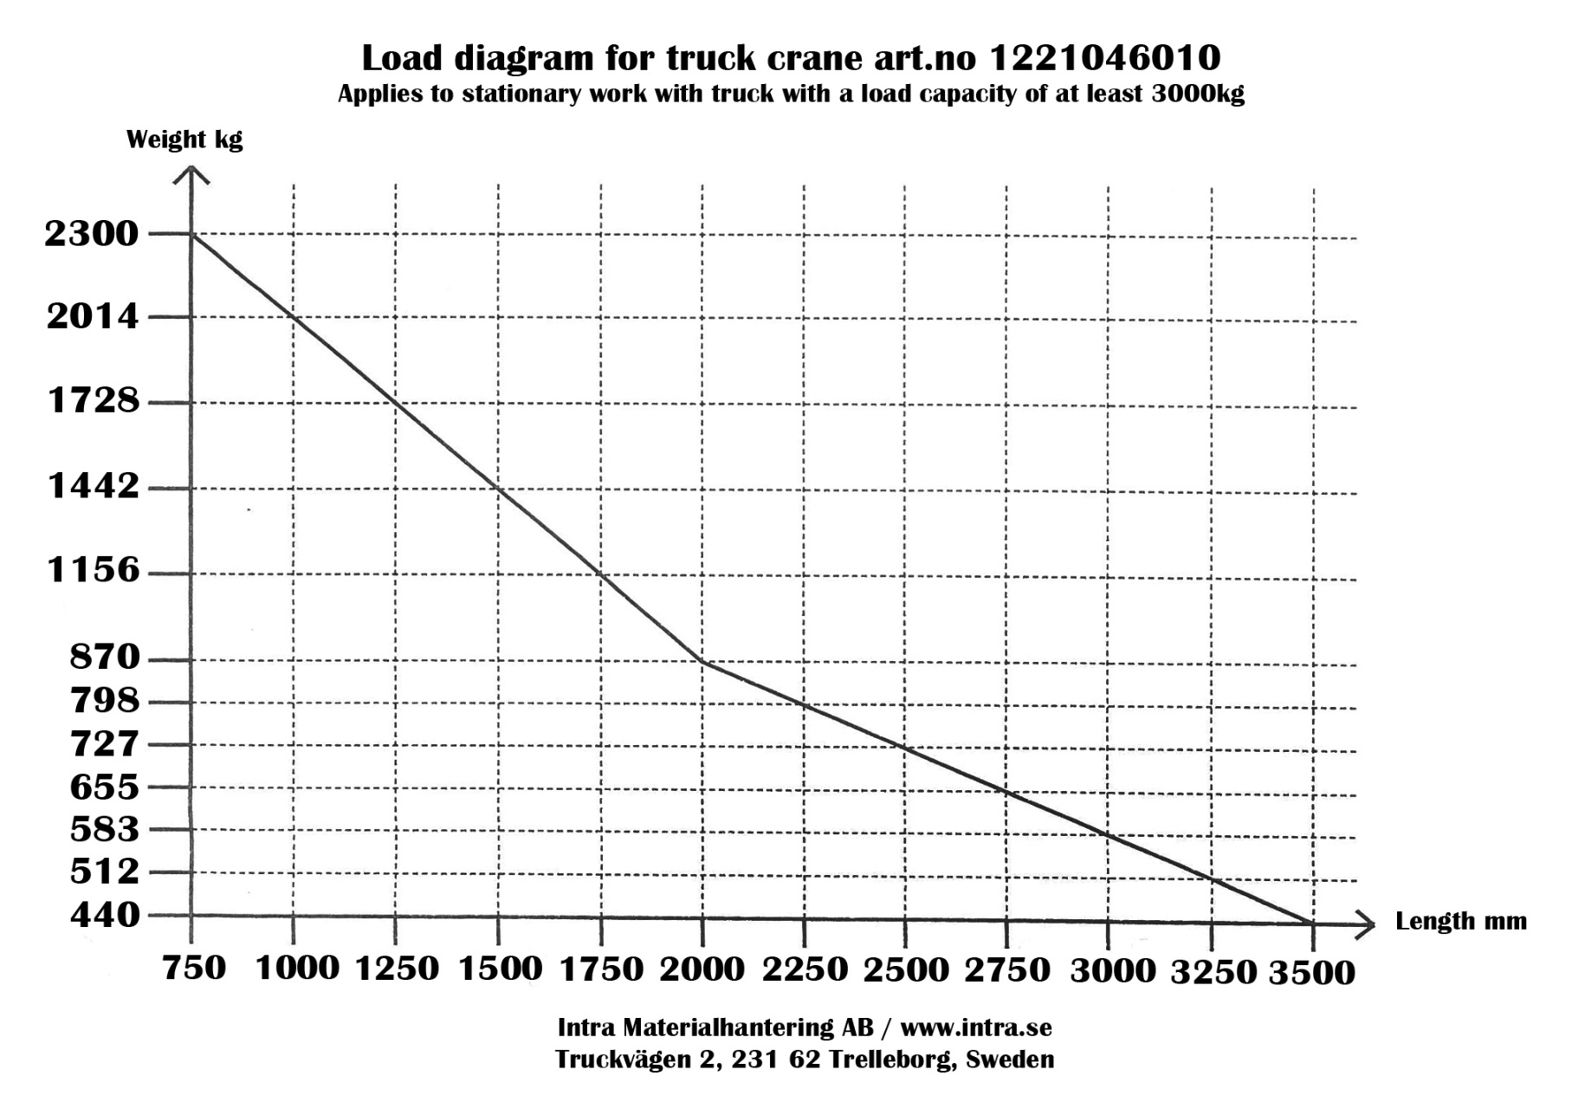

Load limits for stationary truck with max. lifting capacity of 1.5 metric tons.

\
Fully unfolded telescope

Load limits for moving truck with max. lifting capacity of 1.5 metric tons.

)

\
Fully unfolded telescope

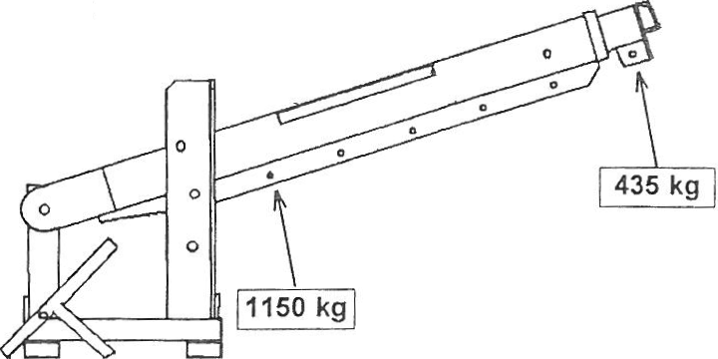Load limits for stationary truck with max. lifting capacity of 1.5 metric tons.

Fully folded telescope

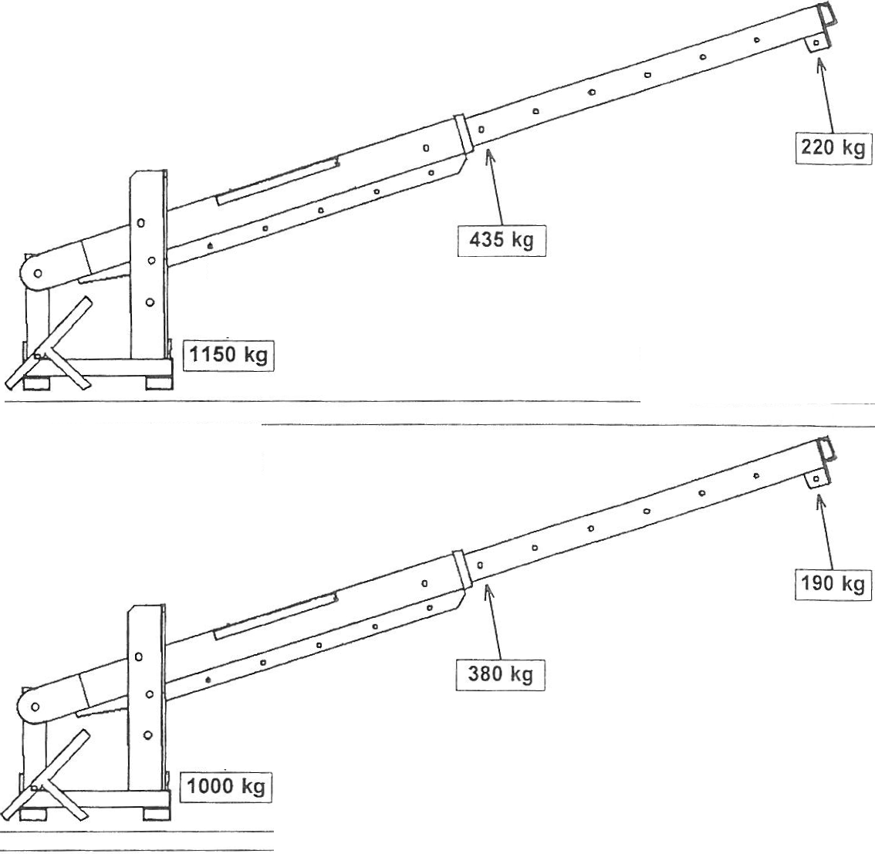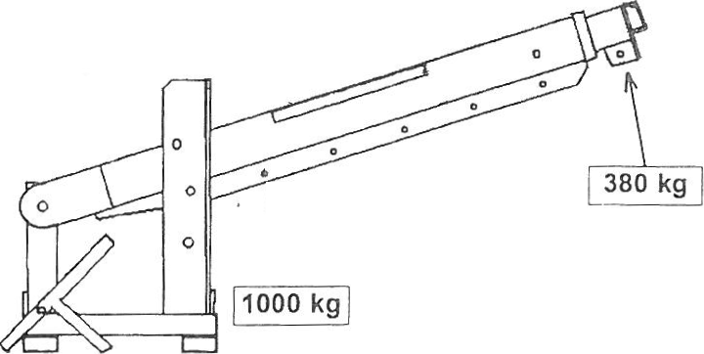Load limits for moving truck with max. lifting capacity of 1.5 metric tons

\

Fully folded telescope I
I
- ------- --- - ----- J

Load limits for stationary truck
with max. lifting capacity of 2 metric tons.

Fully unfolded telescope

Load limits for moving truck with max. lifting capacity of 2 metric tons.

\
Fully unfolded telescope

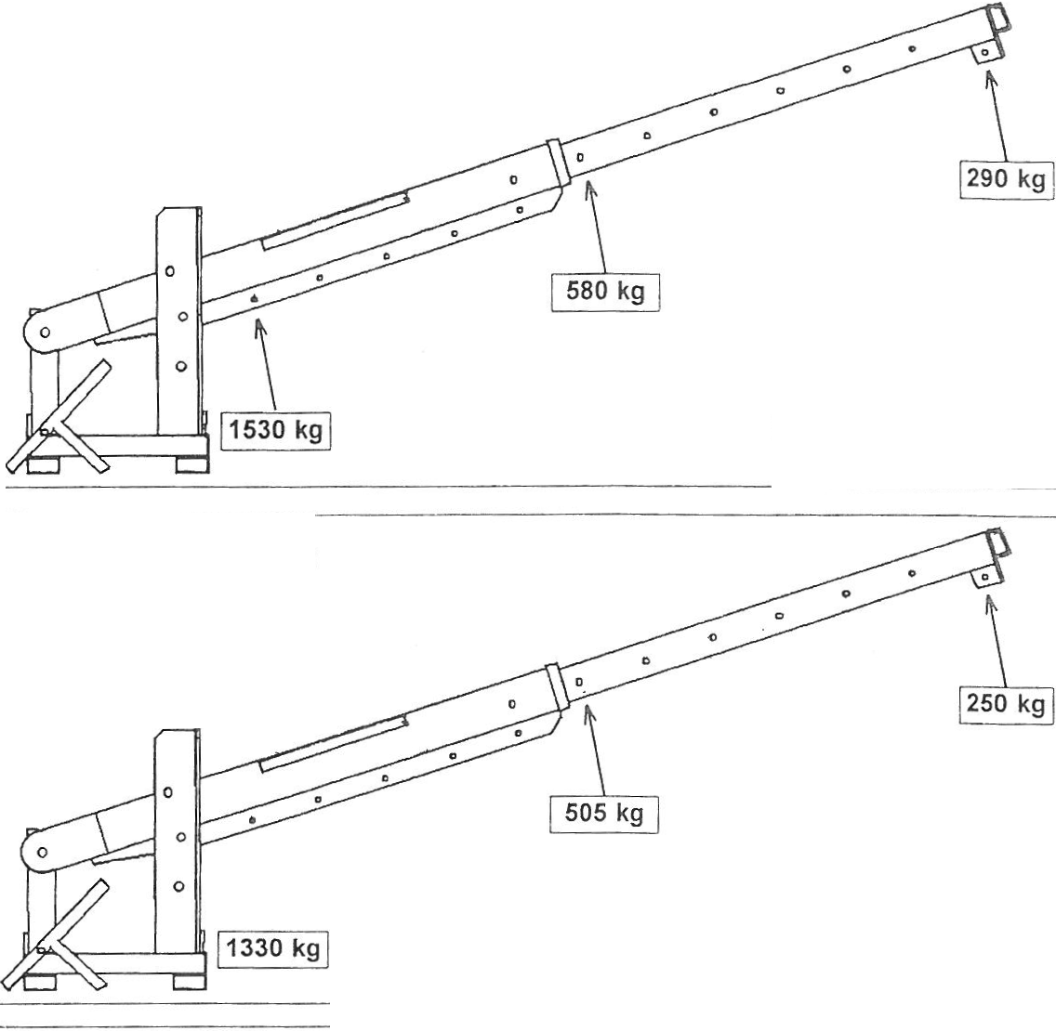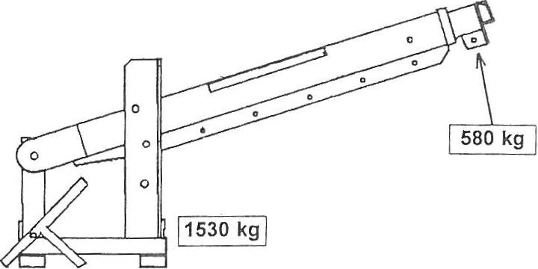Load limits for stationary truck with max. lifting capacity of 2 metric tons.

\

Fully folded telescope

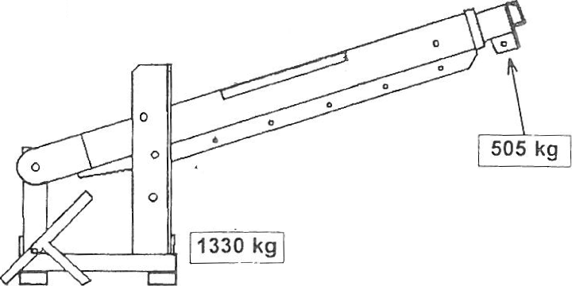Load limits for moving truck with max. lifting capacity of 2 metric tons.

\

Fully folded telescope I
-- _ _ _ )

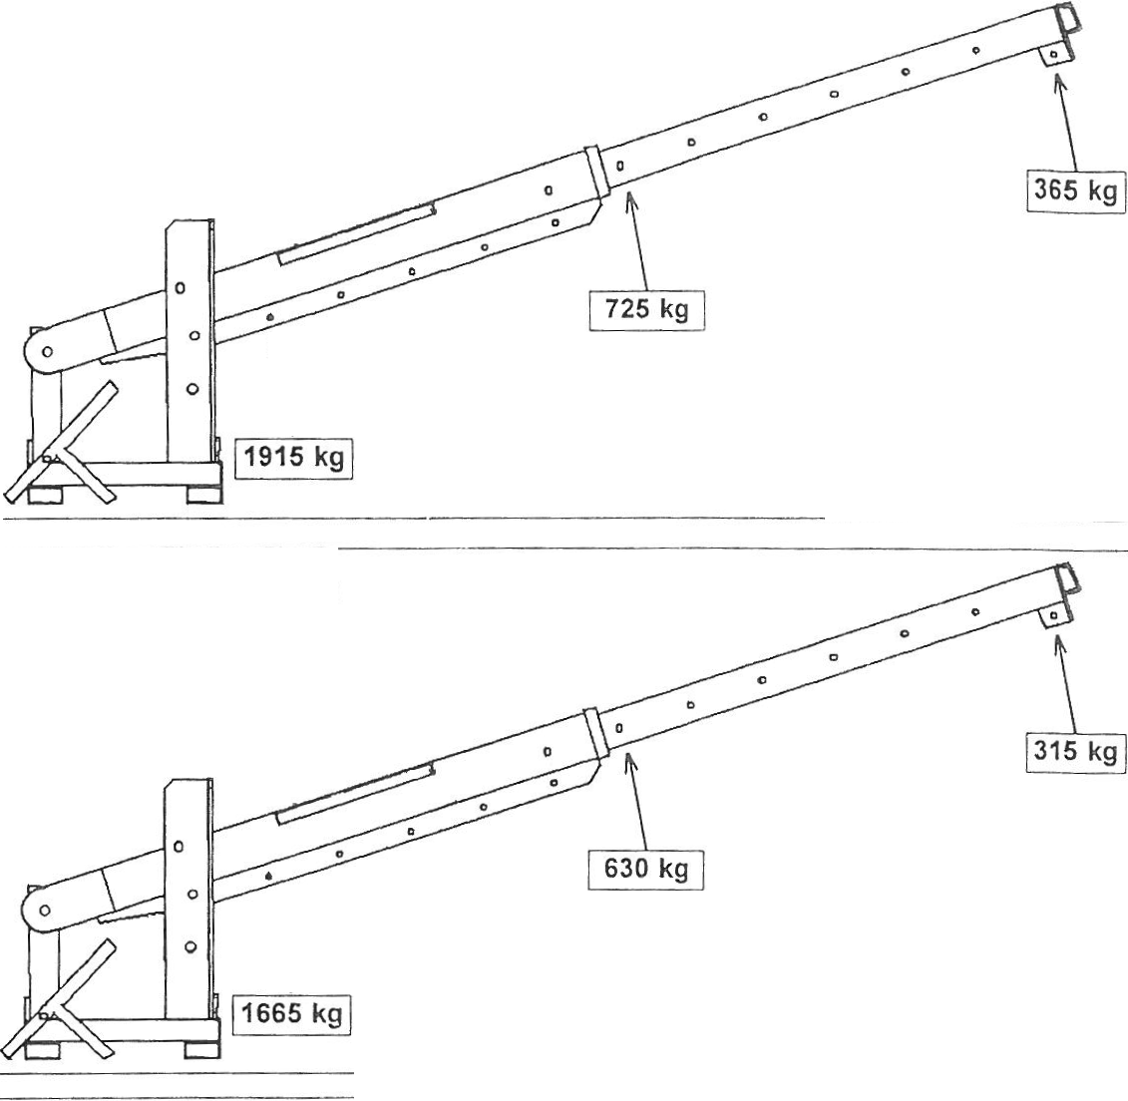----· -- -- - ------ - ----- -
Load limits for stationary truck with max. lifting capacity of 2.5 metric tons.

\
Fully unfolded telescope

Load limits for moving truck with
max. lifting capacity of 2.5 metric tons.

\
Fully unfolded telescope

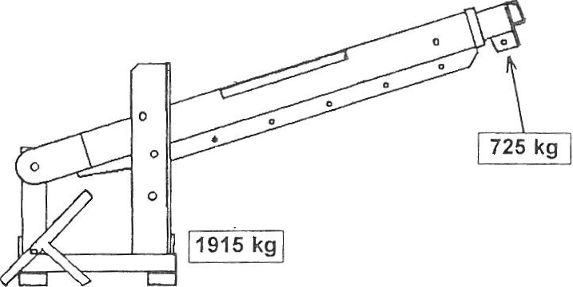Load limits for stationary truck with max. lifting capacity of 2.5 tonnes.

\

Fully folded telescope

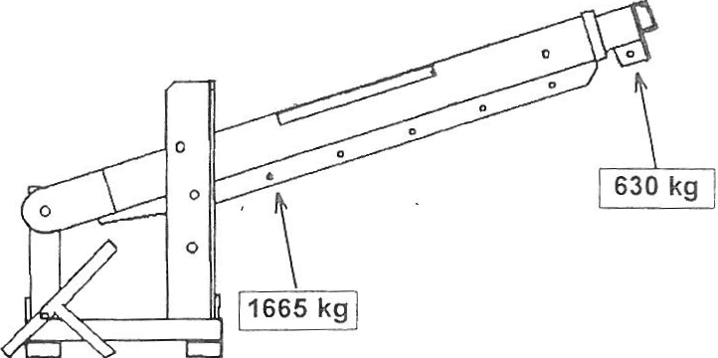Load limits for moving truck with max. lifting capacity of 2.5 metric tons.

Fully folded telescope
I

------ --- ------
·--- ·----- -- ---- - j

Load limits for stationary truck with max. lifting capacity of 3 metric tons.

\
Fully unfolded telescope

Load limits for moving truck with max. lifting capacity of 3 metric tons.

Fully unfolded telescope

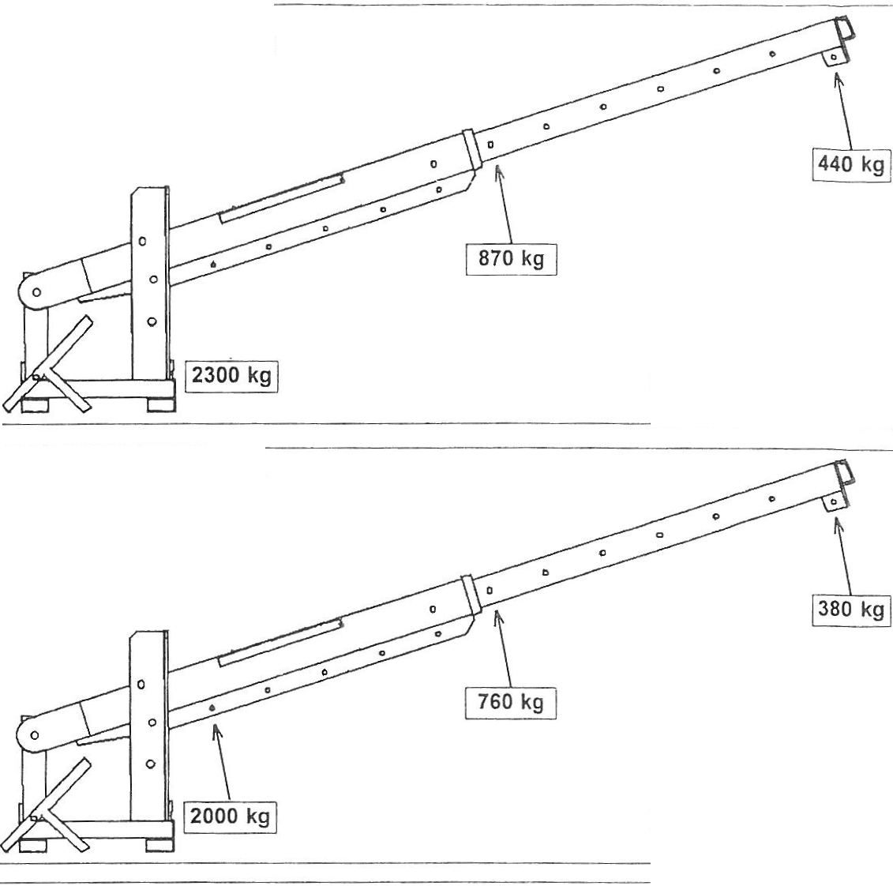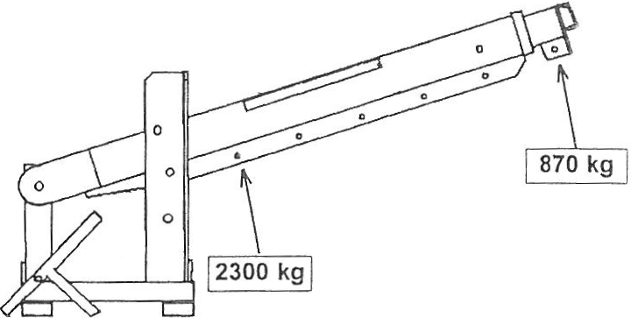Load limits for stationary truck with max. lifting capacity of 3 metric tons.

Fully folded telescope

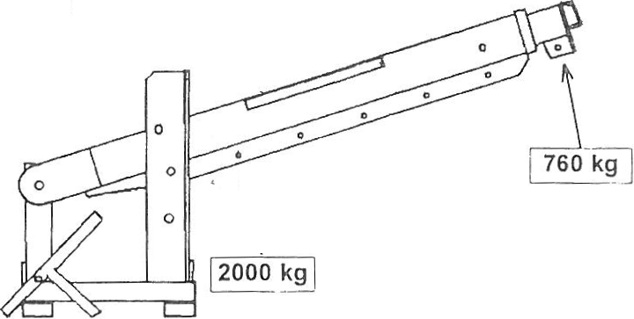Load limits for moving truck with max. lifting capacity of 3 metric tons.

\

Fully folded telescope
I
L ---------· --- --- --- - ------- --- ---

