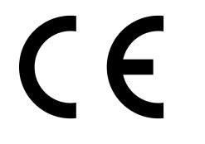
Intra Materialhantering AB, Truckvägen 2, SE-231 62, Trelleborg, SWEDEN
Manufacturer or his authorized representative in Community

Type | Serial No.
1860050305

MLT300 Stainless Lifting Table Screw type 300kg
Authorised signatory

Anders Hylén
Trelleborg 2021/02/09

EU DECLARATION OF CONFORMITY

The signatories hereby certify that the specified product conforms to the EU Directive 2006/42/EC (Machine Directive) including the amendments as translated into national legislation of the member countries. The signatories are in each case individually authorized to compile the technical documents.

